Literature Review (Mike)
System Specifications (Syamil) done
User Stories (Syamil) done
Functional Requirements (Syamil) done
Non-functional Requirements (Syamil) done
Updated Design Specifications (Mike) done
System Implementation (Mike, zhi jake)
System Architecture – Overall system, UI app, server, sensor
Source Code Hierarchy (Zhi) done
Summary of what was achieved (Syam) done
Reflective comments on the success of the project, both from a technical and a project management perspective, including group working issues (Jake)
- dev methodology ??
Appendix:
-Test Cases (Syam)
-Minutes (done)
-User Manual (Syam ZHi)

Updated System Specification 3
User Stories 3
Functional Requirement 5
Non-functional Requirement 6
Updated Design Specification 8
User Interface 8
User Interface at Launch 8
Navigation Drawer 9
Map page 10
Find page 11
Where page 12
Settings page 13
About page 14
System Implementation 15
Major System Components 15
Android Applications 15
Online Server 15
MySQL Database 18
Overview of Developed Source Code Hierarchy 19
Directory Structure of an Android Project 19
Project Directory of Sensor Module 21
Project Directory of User Application 22
Server Directory 25
Software Development Tools 28
GitHub 28
ADT Bundle 28
Summary of Project Milestones achieved 28
Bibliography 30

Updated System Specification

User Stories
As a | I want to | So that
Student | Find a red parking spot near to my class | I don’t have to walk for a long distance
Lecturer | Park close to my office | I can be in office faster
Car owner | Have more efficient parking under new parking policy implemented in UNMC | I could spend less time looking for an empty parking space
Car owner | Find empty parking space quickly | Less petrol is used and less pollution done
Car owner | Remember where I parked my car | I can quickly get to my car and go home sooner
Car owner | Know the exact location of the available parking lots | I don’t need to waste time randomly searching for one
Car owner / App user | To have a user-friendly system to help them find parking | Don’t need to go through steep learning curve in order to use it
Car owner | Check for empty parking slots in real-time | I can straight away go to an empty parking space
App user | Have a user manual | I can learn how to use the application for the first time using it
Developer | Have a vehicle detection algorithm by image processing | Detect availability of parking lot using the image captured
Developer | Have old android phones | I could use its camera as a sensor to detect parking lot availability
Developer | Have a server | I could use it as a communication platform between user application and sensors
Developer | Have a wide compatible interface | Most users may be able to use the developed application
Developer | Have a small-scale model of cars and map | I could use it for demonstration purpose
Developer | Have a secure server | Data integrity could be maintained
Developer | Have continuous power supply to sensor phone | It could operate over designated time frame
Developer | Have an online database | Could store and distribute data in an organized way
Developer | Have a shelter for sensor android phones | It won’t be easily damaged due to external factors
Developer | Create in-app user guide and user manual documentation | Users can learn how to use the application independently
Developer | Create an app feature which finds parking based on user’s preferences | Users can find parking spots in close proximity to their designated location
Developer | Create an app feature to save the location where the user parked | Users can always check where they parked their cars
Developer | Display the open source licenses of the external libraries used in app development | Credits are given to the open source software developers

Functional Requirement

- The sensor application should be able to detect if there is a vehicle parked on its assigned parking bay.
  - The sensor application will make use of the phone camera to take picture once per every 7 seconds interval.
  - The sensor application will compare the latest two consecutive images for the difference in pixel values. If the difference exceeds a pre-set threshold, the application will decide that vehicle is detected.
  - The sensor application will update the online database status if a vehicle is detected.

- The mobile application requires Internet connection to operate.
  - The mobile application will automatically establish Internet connection when started.
  - The mobile application will not crash if it fails to connect to the Internet.
    - The mobile application will display a dialog box to prompt the user to check for network connection.
    - The mobile application will not be able to display and run all Internet bound activities.

- The mobile application should be able to display a small-scale prototype car park map.
  - The map layout should be displayed automatically when users start the application.
  - The map layout should represent red and yellow parking zones correctly.
    - Red parking bays should be labelled with red colour.
    - Yellow parking bays should be labelled with yellow colour.
  - The map layout should indicate all map objects with name labels.
    - Parking bay objects should be labelled with parking bay number.
    - Building objects should be labelled with the building name.
  - The map layout should indicate which parking bays have been occupied.
    - Occupied parking bays should be greyed out.

- The mobile application should be able to present a real-time status of the car park information.
  - The mobile application shall constantly pull data from the server to ensure it always has the latest instance of the car park information.
  - Parking bay will be shaded once it is occupied.
  - Parking bay will be unshaded once it is available again.

- The mobile application should allow the users to interact with the user interface.
  - The mobile application should enable users to navigate between Activities.
    - A navigation drawer will be expanded by the user swiping from the left edge of the screen or by touching the app icon on the action bar.
    - The navigation drawer will have the options of pages that the users can navigate to.
    - The navigation drawer shall be able to be dismissed.
  - The map view should be zoomed in when users pinch open.
  - The map view should be zoomed out when users pinch close.
  - The map view should be scrollable with swipe or drag gestures.

- The mobile application should allow the users to find empty parking spots according to their preferences.
  - The mobile application should allow the users to input query.
  - The query details shall encompass parking type (red / yellow) and a designated building.
  - The mobile application will search for any empty parking bays within closest proximity to the selected building and highlight the results in the map.

- The mobile application should enable the users to save their parking spot locations.
  - The mobile application will highlight the parking bay saved by the user to indicate its location on the map.
  - The saved preference shall persist even after the application was terminated, and always available to be shown to the users whenever they need it.
  - The mobile application should allow the users to overwrite the previously saved parking location with a new parking location.

- The mobile application should provide user guide to assist first-time users.
  - User guide will be demonstrated in the form of a series of popup messages.
  - User guide will give the users an overview of the application’s features and step the users through their first user experience.

- The mobile application should provide options for the users to modify its settings.
  - The mobile application should allow the users to turn on or turn off the user guide feature.
  - The mobile application should allow the users to clear the saved parking location data.
  - The mobile application should allow the users to view the open source licenses of the external libraries that are adopted during the project development.

Non-functional Requirement

- Usability
  - The sensor system will only be operating during the office hours, which is from 8 a.m. to 5 p.m., as the parking issue will not remain a problem off office hours.
  - The mobile application should be usable by people of all ages, gender, races and cultures and also education background especially to those who are in need of parking service in campus.
  - The mobile application should have a simple and intuitive user interface so that even new users can easily learn how to use it in a few runs.
  - The users require Internet access on their mobile phones in order to activate the core functionality of the mobile application.

- Performance
  - The system need to have an algorithm to detect vehicle and it need to be optimized enough to be able to run on low-end android phones.
  - The sensor algorithm must be smart enough to not falsely analyse data if encountered with mild disturbance from the environment.
  - The maximum response time from the system to the users shall not be more than 10 seconds as the sensor keeps replying every 7 seconds while the user app polls the server every 1 second.
  - The sensors need to communicate with the server via wireless network. Therefore, parking lots will need to be equipped with Wi-Fi coverage with internet connection.
  - The mobile applications need to be coded and supported in Java as it is the targeted development environment in Android. The database backend will be running on PHP-MySQL platform.
  - The server shall be able to handle the network traffic and data operations from a saturated car park situation and also a large pool of users.
  - The system shall be capable of handling the actual implementation of a full-fledged university car park capacity.

- Dependability
  - The Android phone shall be able to carry out its required functions properly, such as capturing and processing images.
  - The Android phones (sensors) shall have sufficient power supply to sustain the operations throughout their working hours.
  - The shelter for the sensor shall be strong enough to shield the device from external damaging factors.
  - The user application shall always be in sync with the server.
  - The features of the user application shall not provide misleading information to the users.

- Security
  - The server shall be secured so that the information kept and transmitted across components will not be intercepted and sabotaged.
  - The server shall only provide access to the system administrators who can provide the private key to log in using SSH.

- Compatibility
  - The user application is only available on Android platform.
  - The user application supports a minimum API level of 8, which is Android 2.2 – 2.2.3 Froyo.
  - The user application supports up to the latest API level 19, which is Android 4.4 KitKat.

- Portability
  - The user application shall be able to be installed in all Android devices from Android version Froyo to KitKat.
  - The user application shall be able to function as targeted as long as the device is connected to the Internet.

Updated Design Specification

User Interface
The final interface that was implemented had slight modifications from the initial prototypes that were developed, in various ways:
- It was discovered that the method for navigation between the app’s pages were conflicting with the design guidelines suggested by Google, so the main navigation method decided on was through the use of navigation drawers.
- A proto-type map was implemented, instead of the entire university parking.

User Interface at Launch
At launch, the application checks if the device is connected to the internet.
In the event that it isn’t, the following prompt is displayed:
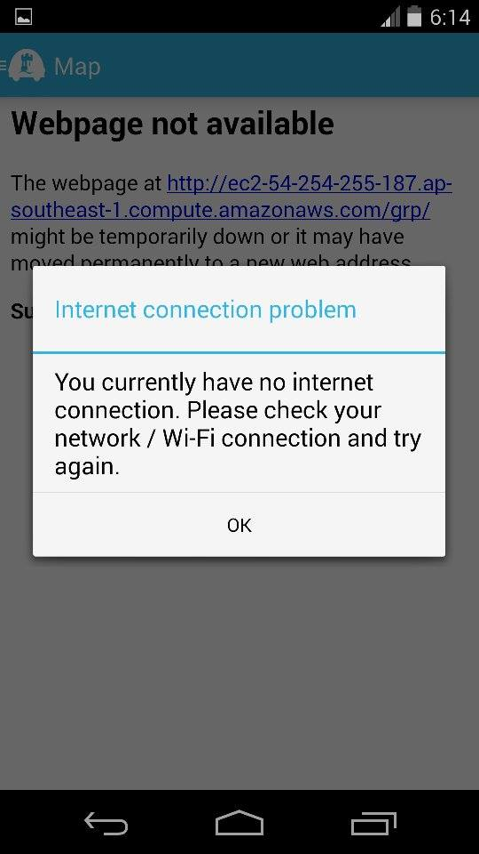
After dismissing the notification, the launch of the app is continued although the pages requiring an internet connection will be non-functional. It has been implemented in this way, as crucial information regarding the parking spot is saved locally.

Navigation Drawer
At the left of the top action bar, a toggle is provided, which on touch opens the navigation drawer as illustrated below:
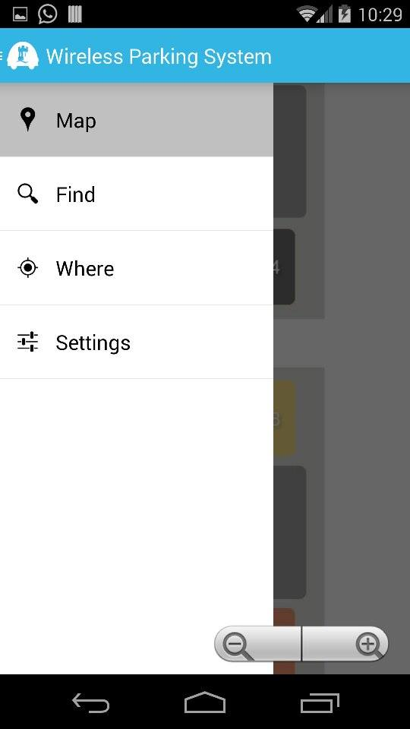
Current page that the user is viewing
Other available pages within the app

Map page
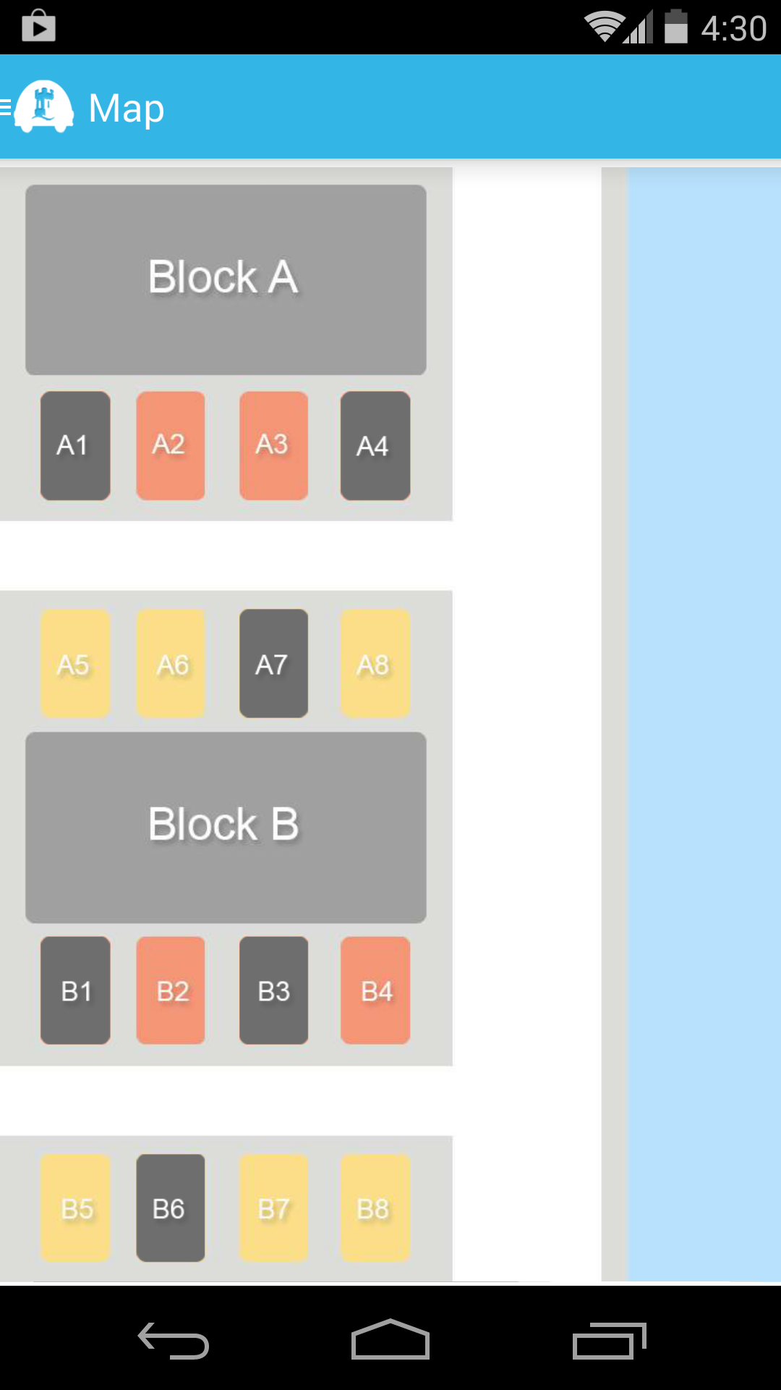
At launch, the first screen that the user sees is the map of the parking lot, along with their availability. A key is used to help for the first time users, with the following configuration:
- Red – The available parking spots usually reserved for the staff and lecturers on campus.
- Yellow – The available parking spots for both staff, lecturers and students
- Black – An occupied parking spot.

Find Page
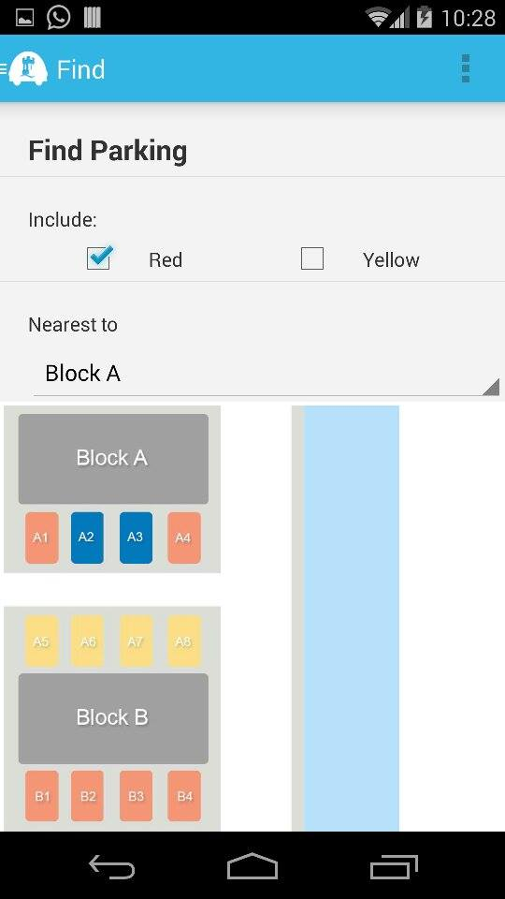
The find page within the app is used to search for a convenient parking location for the user, depending on 2 criteria:
- The type of parking
- Proximity to building that they would like to go to
The results are then highlighted in a dark blue colour, which the user may go to.

Where page
On this page, details of parking location that the user has parked in are saved. Once the user has parked, he selects the parking spot to save his location at. The parking is spot is then saved, listed and highlighted in a dark blue colour.
An example is as shown below:
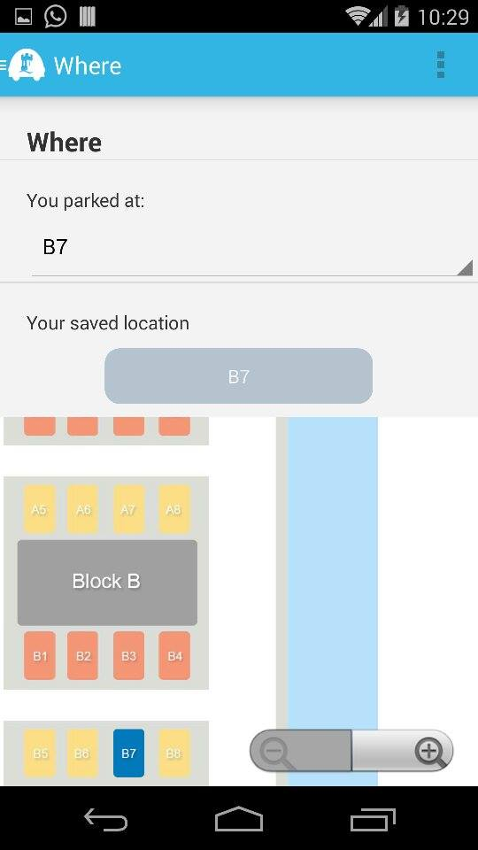
The parking location is saved, even if the user exits the application.

SETTINGS PAGE
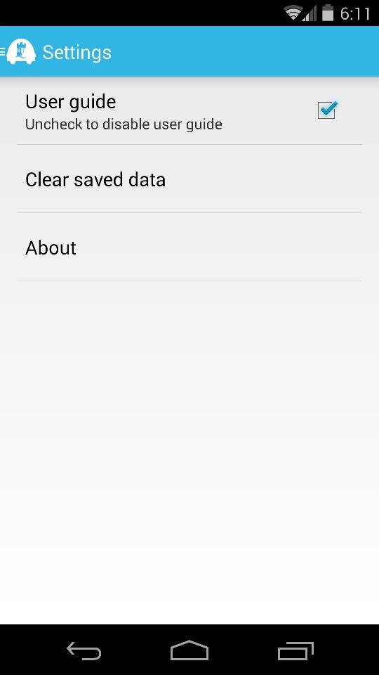

This is the settings page for the mobile app. It contains:
- A toggle for the user guide, which is usually visible during each start-up as notifications. It is implemented as shown below:

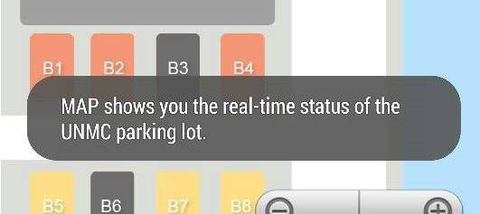

- A button to clear the locally saved information about the parking spot of the user. It is accompanied with the following prompt:

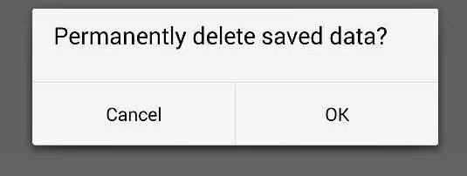

- And a button linking to an about page.

About page
This is the About page, it details out:
- The credits for the mobile application
- The open source code implemented by the application.
Additionally, it has been set out to intentionally go back to the Settings page, instead of the drawer.
Upon selecting the Open Source Licenses button, the following notification is displayed:
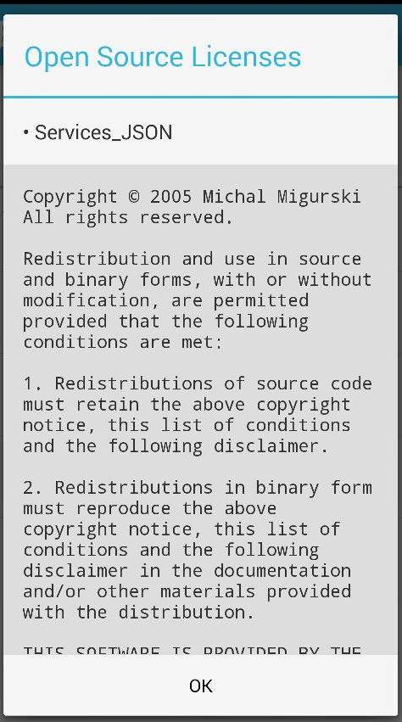
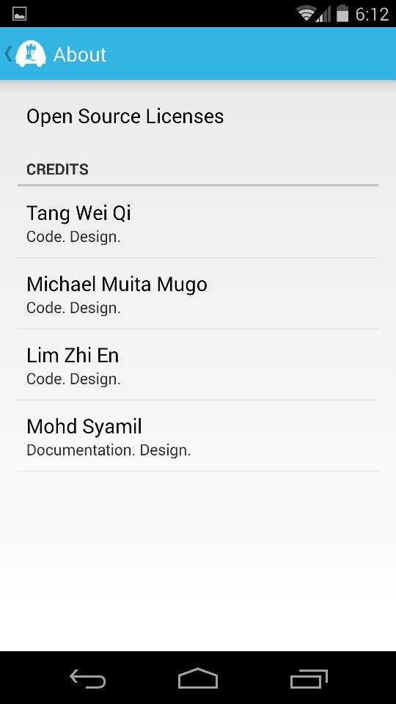

System Implementation

Sensor
With more android phones sold worldwide, there is an increasing abundance in used android phones which are not reused. Out of them many ways to determine a car park status, our team decided to utilize the camera module in these recycled phones to determine the availability of a car parking bays. Basically the recycled android phone itself will act as a sensor which is connected to the Wireless Parking System database through the internet in any means of connectivity. The detection of a car on a parking using a camera module requires an image processing algorithm that is practical enough to runs on used android phones where the hardware capabilities are often outdated compare to the latest technologies available in the market. This poses a challenge to our team to research on and seek on the best way to apply car detection using an android phone.
From our past experiences in the Introduction to Image Processing module, there are numerous ways in determining an existence of an object which is a car in our case. A few of them include edge detections and others advanced algorithms. Since hardware capabilities are limited in our case, we decided to go with the simplest algorithm in detection where we determine the differences between consecutive images and figures how much changes are there. The sensor application will first convert two images being compared into greyscale and compares every pixel with its relative pixel on the other image and determine the differences in greyscale intensity. If the absolute of the differences between those pixels are higher than a pre-set threshold value, the pixel will be labelled as a changed pixel. The process repeats itself with the rest of the pixels on the images and a changed pixel percentage will be calculated using the formula:
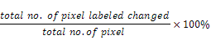
The result represents the percentage of pixel changed according to the intensity threshold predetermined. Higher percentage indicates that there is a huge change in those pictures compared. As the position of the sensors is fixed in a way that the camera monitors a particular parking bay, there won’t be any big changes in the consecutives images unless there is a car introduced into the camera frame. With this theory, the changes in status of a parking bay can be determined by a huge percentage of pixels changed.
By the implementing the algorithm mentioned above with a flipping switch, the status of the parking bay could be determined in the condition that the parking bay is vacant in status during initialisation of the sensor and the first significant change in pixel indicates there is an introduction of a car into the bay. For example, sensor at a particular parking bay is initialise and every frequent comparison of the relative images indicates minimum changes will show that that particular bay is not yet occupied by any car and vice versa. Once the status of the bay is taken, the next huge change would indicate the car has left and yet again it is vacant.

Connecting Android to MySQL
In order to allow our sensor app to directly update the centralized database in real-time basis, we need to devise a mean of communication between Android and MySQL. Through research we found a way to do so, which is to use PHP as the intermediate platform to connect Android with MySQL.
Basically, this is how the above architecture works. The Android app calls a PHP script to perform a data operation, such as “Update”. The PHP script then connects to your MySQL database to perform the operation. So the data flows from the Android app to the PHP script then finally is stored in the MySQL database.
(RaviTamada, 2012)

Online Server
The nature of our project requires a centralized database for simultaneous data retrieval from multiple user application. This criterion has set up our requirement to obtain an online server where the MySQL database will be populated. Aside setting up an online server, we can hardly find any other easier ways achieve this task. While keeping in mind that the online servers usually do not come without cost, we started our “hunt” for an online server which will not cost us a single penny at all. Fortunately, we came across Amazon Web Services (AWS), a collection of remote computing services that together make up a cloud computing platform, offered over the Internet by Amazon.com. One of the major services provided by AWS, which is the Amazon Elastic Compute Cloud (EC2), perfectly fulfils our needs.

Amazon Elastic Compute Cloud (EC2)
EC2 provides resizable computing capacity in the AWS cloud and allows us to launch as many or as few virtual servers, known as instances, as we need. With EC2, we can quickly obtain and boot new server instances within minutes, allowing us to quickly scale capacity, both up and down, as our computing requirements change.
Instances and AMIs
An Amazon Machine Image (AMI) is a template that contains a software configuration (for example, an operating system, an application server, and applications). From an AMI, you launch an instance, which is a copy of the AMI running as a virtual server in the cloud.
Regions and Availability Zones
Amazon EC2 is hosted in multiple locations world-wide. These locations are composed of regions and Availability Zones. Each region is a separate geographic area. Each region has multiple, isolated locations known as Availability Zones. Amazon EC2 provides you the ability to place resources, such as instances, and data in multiple locations. Resources aren't replicated across regions unless you do so specifically. In our case, we launched our instance in Asia Pacific (Singapore) Region (code: ap-southeast-1) as it is geographically the nearest location to our working station.
Amazon EC2 Key Pairs
Amazon EC2 uses public–key cryptography to encrypt and decrypt login information. Public–key cryptography uses a public key to encrypt a piece of data, such as a password, then the recipient uses the private key to decrypt the data. The public and private keys are known as a key pair.
To log in to our instance, we have created a key pair (myserver.pem). We have to specify the name of the key pair when we launch the instance, and provide the private key when we connect to the instance. Linux/Unix instances have no password, and we use a key pair to log in using SSH.
Security Groups
A security group acts as a virtual firewall that controls the traffic for one or more instances. When you launch an instance, you associate one or more security groups with the instance. You add rules to each security group that allow traffic to or from its associated instances. When we decide whether to allow traffic to reach an instance, we evaluate all the rules from all the security groups that are associated with the instance.
We have selected Bitnami LAMP stack as the security group of our instance because it is completely integrated and configured. It includes ready-to-run versions of Apache, MySQL, PHP and phpMyAdmin and all of the other software required to run each of those components. As such, Bitnami LAMP stack greatly simplifies the development and deployment of our PHP applications and we will be ready to start working as soon as the AMI is launched onto the Amazon EC2.
AWS Free Usage Tier
The interesting point is, AWS is offering free usage tier to help new customers get started in the Cloud. The free tier can be used for anything you want to run in the Cloud, including EC2 and it will be available for 12 months following our AWS sign-up date. This is the deciding factor that makes us choose Amazon EC2 as our online server because it will be free-of-charge for one year, at least covering our requirements throughout the entire project timeframe.
(AWS)

Connecting to Server
Linux/Mac users
As Linux and Mac OS X come bundled with SSH clients by default, in order to connect to the server using SSH, the Mac users in our group need to open the terminal and type the following:
ssh -i myserver.pem bitnami@ec2-54-254-255-187.ap-southeast-1.compute.amazonaws.com
Windows users
Windows does not come with a bundled SSH client by default. So, those of us who are Windows users will have to use the freely available Putty utility to connect to the server. SSH key in PPK format is also needed for authentication.
(MindTouch Core)

Description of our EC2 Instance
Public DNS | ec2-54-254-255-187.ap-southeast-1.compute.amazonaws.com
Public IP | 54.254.255.187
Availability zone | ap-southeast-1a
Security groups | LAMP
Key pair name | myserver

MySQL Database
We need a database to store all the data required to sustain the operation of our system. EC2 has provided us a very easy-to-use phpMyAdmin infrastructure to handle the administration of MySQL over the web. The database is named “wireless_parking” and it is set up in the localhost of our EC2 instance. It contains only one table, the “main_parking”. We will give you a visual representation of our database in a table form as shown below.
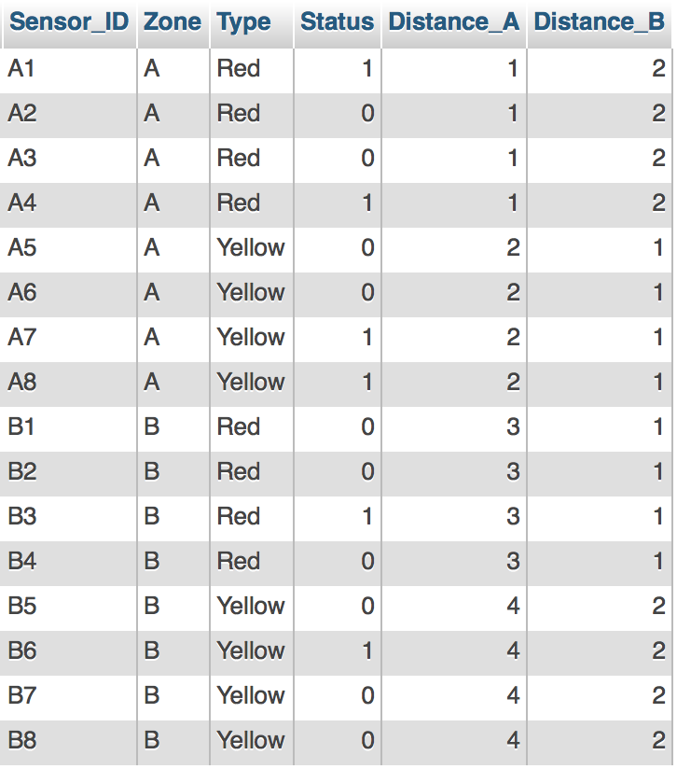

Field description
Sensor_ID | Primary key for each record. Equivalence of parking bay ID. Each parking bay corresponds to a unique Sensor_ID belonging to each sensor device.
Zone | Car park zone. Implied by the prefix of the Sensor_ID.
Type | Category of parking lot. Red signifies Student Parking. Yellow signifies Staff Parking.
Status | Availability of each parking bay. 1 signifies Occupied. 0 signifies Vacant.
Distance_A | Metadata of distance from Block A. Scale of 1 to 4 with 1 signifying the nearest and 4 signifying the furthest.
Distance_B | Metadata of distance from Block B. Scale of 1 to 4 with 1 signifying the nearest and 4 signifying the furthest.

User Interface
The application follows the fragmentation guidelines of Android. It contains 4 fragments, along with an adapter and model to manage the navigation drawer and a main activity to connect all the components together. Along with this, various styling information and resources were modified to implement the application in a single frame layout, to enable navigation through a drawer.
This was adapted from the following referenced:
Tamada, R (2013) Android Sliding Menu using Navigation Drawer. Source Code. http://www.androidhive.info/2013/11/android-sliding-menu-using-navigation-drawer/

Background
Following the upgrade in the Android ecosystem into the Jelly bean and future versions, Google implemented a new standard in navigation for all mobile applications. It entails the representation of the portions of a user interface in an activity. These representations are known as fragments.
The following diagram illustrates the concept behind the use of fragments for navigation:
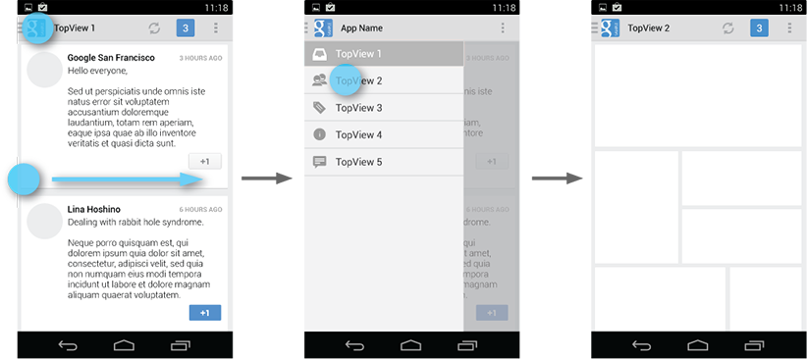 Source: http://developer.android.com/design/media/navigation_drawer_overview.png
The user accesses the drawer by swiping from the left edge of the screen or by touching the application icon on the action bar. As it opens, it overlays the content but not the action bar.
The panel that displays app’s main navigation options on the left of the screen is implemented by declaring the main user interface component as a DrawerLayout object as the root. Inside it, two child views are used:
- FrameLayout to contain the main content (This is populated by the fragments at runtime)
- ListView to contain a list of the various pages available within the app.
At start-up, the navigation drawer’s list of items are populated, by the use of an adapter which basically provides a series of calls that connects all the various resources, such as strings, styling and images (stored in various sections of the app) together. The items are then associated with an action listener, which connects to changes the fragment viewed on the main activity. They are pre-assigned by default, and upon selection, the main activity’s fragments are changed.

Layouts of individual pages
Each Fragment has been assigned a unique xml layout, often containing multiple nested linear layouts, weights and alignments to ensure compatibility with various screen sizes.

Overview of Developed Source Code Hierarchy

Directory Structure of an Android Project
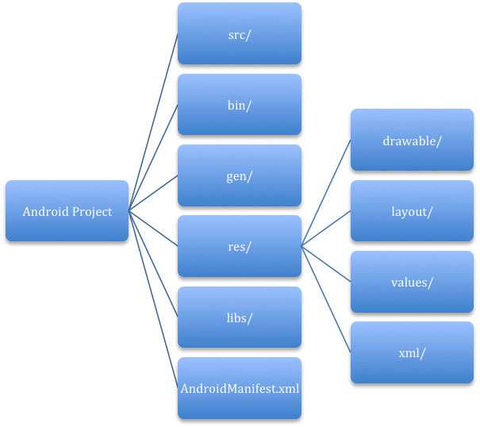
Android Projects
An Android project is the container for your application's source code, resource files, and files such as the Ant build and Android Manifest file. An application project is the main type of project and the contents are eventually built into an .apk file that you install on a device.
src/
Directory for your app's main source files. By default, it includes an Activity class that runs when your app is launched using the app icon.
bin/
Output directory of the build. This is where you can find the final .apk file and other compiled resources.
gen/
Contains the Java files generated by ADT, such as your R.java file and interfaces created from AIDL files.
res/
Contains several sub-directories for app resources. Here are just a few:
drawable/
Directory for drawable objects (such as bitmaps)
layout/
Directory for XML files that are compiled into screen layouts (or part of a screen)
values/
Directory for XML files that contain a collection of resources, such as string and color definitions.
xml/
For miscellaneous XML files that configure application components.
libs/
Contains private libraries.
AndroidManifest.xml
Every application must have a manifest file in its root directory. It presents essential information about your app to the Android system, information the system must have before it can run any of the app's code.

Project Directory of Sensor Module
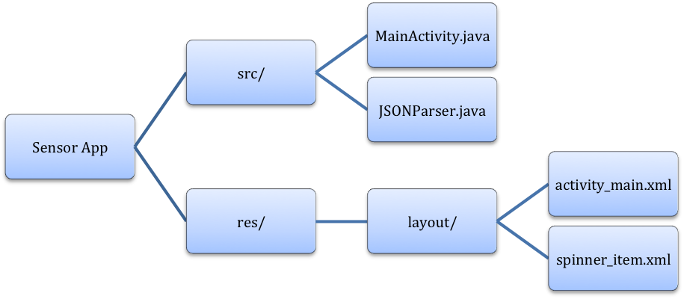
Android Web Service
In the sensor app, we created an Android Web Service to transmit data over the Internet to the server-side PHP scripts via HTTP POST request. The response hence replied by the server will be encoded in JSON data structure because it is very light weight, structured, easy to parse and much human readable. These characteristics make JSON the best alternative to XML when your Android app needs to interchange data with your server.
In order to prevent the HTTP requests from hogging up the UI thread, we are getting the JSON by making the HTTP calls in AsyncTask. With AsyncTask, the HTTP calls are executed in the background thread while the results are then pushed to the UI thread to be displayed.
JSON Parser
Since we are getting JSON as server response, we need a JSON parser in our Android sensor app to correctly display the response from the HTTP calls made. For the JSON parser, we have adopted an open-source JSON Parser class source code from AndroidHive.
Within the doInBackground method of the AsyncTask, two parameters are encapsulated into NameValuePairs to be sent over through HTTP POST request, namely the Sensor ID and the Status. Status parameter will be a boolean value indicating the vacancy of the specified parking bay represented by the unique Sensor ID parameter. These NameValuePairs along with the destinated URL and the HTTP method will be passed to the JSON Parser. JSON Parser will send the HTTP request to the specified URL and return a JSONObject of the server response. Hence, in the onPostExecute method of the AsyncTask, the sensor will output a server response string to inform the users of the success of the data transmission.

Project Directory of User Application
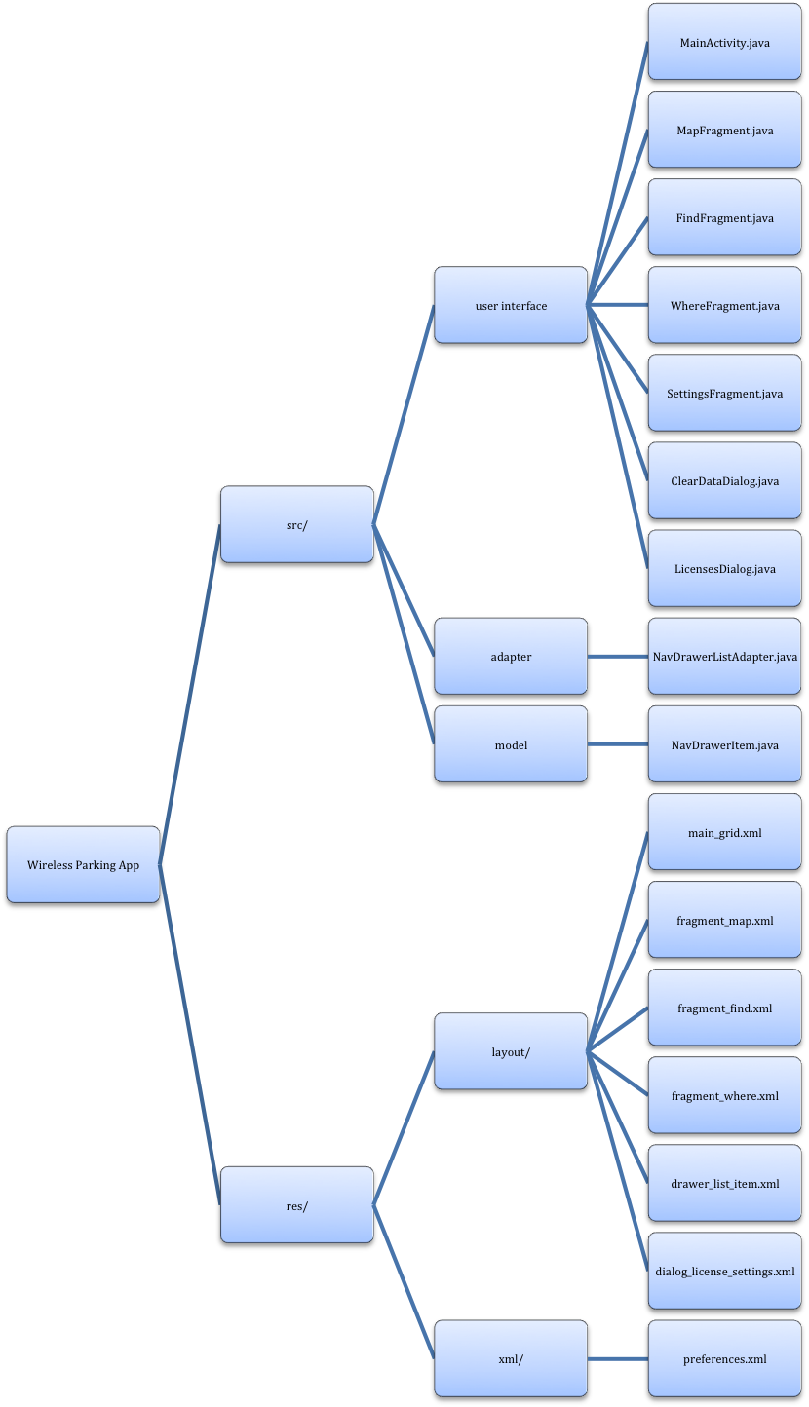

Server Directory
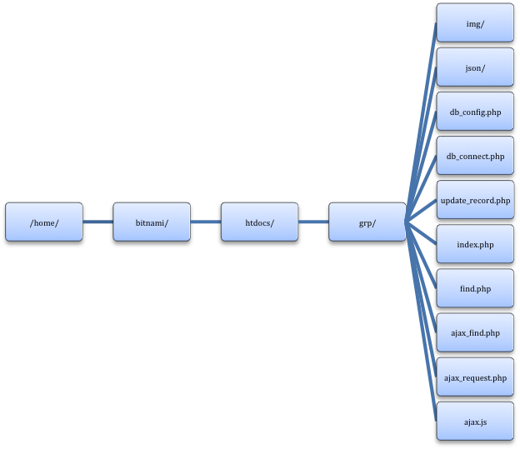

PHP Scripts
All the core functions of our system involve sending data to and fetching data from the database. We plan to use the embedded SQL libraries of PHP to access the MySQL database in the server localhost. Therefore, we populated our server with PHP scripts designed to accomplish this.
db_config.php merely contains all the database connection variables to be used to connect to the MySQL database later on. Four variables are defined and they are as follows:
DB_USER: root
DB_PASSWORD: bitnami
DB_DATABASE: wireless_parking
DB_SERVER: localhost
db_connect.php is the main engine which does the work of establishing a connection with the MySQL database. Before doing so, it first imports the constant variables defined in db_config.php. Then, it uses the DB_USER and DB_PASSWORD to log in to MySQL and DB_DATABASE to connect to our selected database. Finally, it returns the connection to whichever PHP scripts requesting for it.
update_record.php is the server backend of the sensor app. It receives two HTTP parameters, Sensor ID and Status, sent from the sensor via POST method. These two parameters will be submitted as part of the MySQL query to update the database. The MySQL command we use for this is UPDATE and with the WHERE clause we selectively update the record which meets the condition. In our case, we select the record which has the same Sensor ID as the Sensor ID parameter and update its Status field with the Status parameter sent over. The PHP script will check whether the MySQL operation succeeded or failed and generate a response message. The response message will be converted to JSON before it is echoed back to the sensor app through the web.

Map rendering
How do we render the car park map on our Android user app?
We figured a brilliant way which simplifies everything, which is to use the WebView and web scripting for the map design. The graphical layout of the map is designed using Photoshop. On top of that, we created a library of sprites as masks for each individual parking bay. Each sprite will have the exact same coordinates as the corresponding parking bay in the original map’s blueprint. The idea here is to overlay the entire collection of sprites on top of the original blueprint and manipulate the visibility of each mask by using JavaScript, in accordance to the current instance of the parking space availability. The content of the map is defined as <img> elements in HTML. A bit of CSS is used in setting the position, layering and display options of the sprite images. Using the class attribute, all sprites are classified as one category to facilitate manipulation later. Each sprite will be assigned an id as of the Sensor ID in the database. Hence, each sprite is mapped with its corresponding database entry.
How do we make the map instance real-time?
This is where AJAX comes into place. AJAX, or in full Asynchronous JavaScript, is the art of exchanging data with a server, and updating parts of a web page, without reloading the whole page.
How it works?
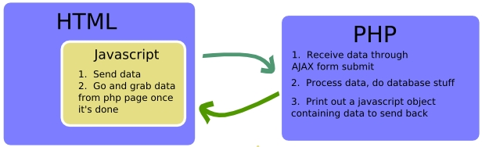
(Simple AJAX)
JavaScript submits a form to a PHP page using AJAX. As soon as the server-side PHP has received the data through AJAX form submit, it will process them and carry out database operations. After PHP is done with works, it will print out a JavaScript object containing data to send back to the client-side JavaScript. The JSON-PHP module can convert a PHP array of key-value pairs to this JSON object. JSON is a lightweight data-interchange format based on a subset of the JavaScript Programming Language, Standard ECMA-262 3rd Edition - December 1999. It is easy for humans to understand and for machines to parse. JSON is a text format that is completely language independent, thus makes it an ideal data-interchange language.
Back to our case, we have two JavaScript functions, ajax_request and ajax_response. Ajax_request will submit the form to ajax_request.php through AJAX and then calls the ajax_response function when AJAX data has been retrieved. The retrieved data will be passed on to ajax_response as a JSON object parameter. The JSON object returned contains all key-value pairs from the database with key being the Sensor ID and value being the Status at that particular instance. Within the ajax_response function, we get hold of all the sprites by class name, perform cross-reference checks with the retrieved data and then toggle the visibility of each sprite according to its current status. In order to have the map instance real-time, we used JavaScript’s setInterval method to repeatedly poll ajax_request.php for the latest changes in the database and then update the web page accordingly.

Open Source Libraries
Our server-side map rendering implementation uses the following open source modules:
AJAX JSMX library
JSMX is an Ultra Lightweight - Language Agnostic - Ajax Framework. It is by far the easiest way to integrate Ajax into any Web Application. What separates JSMX from most other Ajax Frameworks is that the JSMX API runs entirely on the client and has no Server Side Components to install. Given this fact plus the fact that you can pass back JavaScript, XML, JSON, or WDDX makes JSMX a truly Universal Ajax API.
The beauty of this API is its simplicity and its straight forward syntax. It consists of just one file (engine.js) which marshals requests between the client and the server via the http() function (which is the only function you need to know about in order to use JSMX).
We can see a diagram of the JSMX API below. You simply place the engine.js file in your display page. You then write two functions within JavaScript for each call to the server, a request function and a callback function. The request function makes either a "GET" or "POST" to the server by calling the http() function (which resides in the engine.js file). The server fires off the request and returns JavaScript, XML, JSON, or WDDX to engine.js which in turn converts the response into a valid JavaScript Object/Variable and returns it to the callback function in your display template.
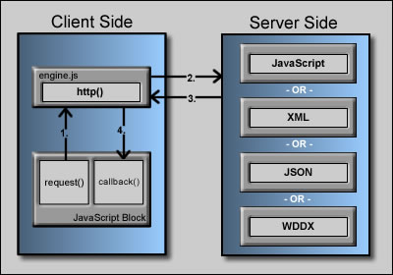
(Lalabird.com)

JSON-PHP library
This package provides a simple encoder and decoder for JSON notation. It is intended for use with client-side Javascript applications that make use of HTTPRequest to perform server communication functions - data can be encoded into JSON notation for use in a client-side javascript, or decoded from incoming Javascript requests. JSON format is native to Javascript, and ca (Simple AJAX)n be directly evaluated with no further parsing overhead.
(The PHP Group)

Software Development Tools

GitHub
GitHub is a web-based hosting service for software development projects that uses the Git revision control system. GitHub offers free accounts for open source projects. All members of the team are obliged to register a user account from GitHub and our repository master created a repository that we all can contribute in. Our online repository is named “wireless-parking-sys” and can be visited at https://github.com/jakebooyah/wireless-parking-sys.
Within the centralized repository, we host our project development directory, which includes source code and documentation materials. A centralized repository ensures that each of us always has reference to the latest version of the project files and everyone can make changes to the same copy of files. This avoids unnecessary branching from the master branch. Each group member has a local copy of repository in their machine and has full control over it. Changes we make to our local repositories can be pushed to the centralized repository so that everyone in the group can see it. For instances when more than one developers work on the same file simultaneously, GitHub has the mechanism to record and merge all the changes made.

ADT Bundle
As new Android developers, we downloaded the ADT Bundle to start developing our apps. It includes the essential Android SDK components and a version of the Eclipse IDE with built-in ADT (Android Developer Tools) to streamline our Android app development.

Android SDK
The Android SDK provides the API libraries and developer tools necessary to build, test and debug apps for Android. The Android SDK Tools package that comes with the ADT Bun (ADT Plugin)dle is not the complete SDK environment but includes only core SDK tools. By using the Android SDK Manager, we downloaded a few other packages that are required for our app development, including Android Support Library, Google Play services and Intel x86 Emulator Accelerator (HAXM).
(Get the Android SDK)

Eclipse IDE with built-in ADT
Android Development Tools (ADT) is a plugin for the Eclipse IDE that is designed to give us developers a powerful, integrated environment in which to build Android applications.
ADT extends the capabilities of Eclipse to let us quickly set up new Android projects, create an application UI, add packages based on the Android Framework API and debug our applications using the Android SDK tools. We really appreciate the guided project setup provided by ADT, as well as tools integration, custom XML editors and debug output pane. Without all these tools, we will not be able to initiate a smooth start in our Android development and complete it in a short time frame.
(ADT Plugin)

Summary of Project Milestones achieved
Basically, our group manage to create a parking system guiding application that operate using three basic components which are sensor, an online database and end user application. These three components are inter-related with each other. These three components were developed based on the requirement that our group set in the early stage of development. Since our group has decided to do agile development method in developing this application, the requirement change from time by time depends on the flexibility of our group in developing it.
For the sensor device, we manage to meet up the requirement that our group discuss in the early stage. We decided to use camera from old android phone as a sensor. This is more eco-friendly and we can cut our cost for this small scale project which our group targeted for on spot registration during open day. By using phone camera as a sensor, we can easily show demonstration on a model map that we have created using some model car. A program was coded and applied in the phone camera to detect the changes in pixel on our model map. Thus this will determine the availability of the car park.
An online database was created by our group. This is for purpose of storing the input of the camera before update it in the end user’s Android phone. The server was coded using SQL language. The database will fetch data from sensor every five seconds as we set in the camera program to capture and process image every five seconds. This data then will be shared amongst all users. It will appear in the map in their application as they open the application. The map will be highlighted if that particular parking lot was taken and if it is not taken, the parking lot will not be highlighted and coloured based on the parking types which are red and yellow.
In the early stage of development, our group has decided to build a parking application with three main functionality which are searching a parking lot near to user’s proximity. User can enter the building that they want to park their car close to and the parking type that they can park. The system then will direct them the nearest parking lot that met their criteria.
Besides that, this application also allows the users to save the location where they park their car. This is to help the user to remember where they park their can just in case they forgot where they park. They just need to click save when they park their car at a particular parking lot. Since this system is not connected with GPS service, the users are required to input their current location to make them easier to find a car park and go to their car park position.
Lastly, to make the application more user friendly, our group decided to make the user manual in our application. This is because it is our target to ensure user can use the application without any problem. By creating user manual, the user can learn step by step to use the application. This will make the application more users friendly and it will not give problem to all users especially for the first time user.

Bibliography
MindTouch Core. (n.d.). How to connect to your Amazon Instance? Retrieved from Bitnami: Amazon Cloud Images Quick Guide: http://wiki.bitnami.com/Amazon_cloud/how_to_connect_to_your_amazon_instance#How_to_connect_to_my_server
RaviTamada. (2012, May 2). How to connect Android with PHP, MySQL. Retrieved from AndroidHive: http://www.androidhive.info/2012/05/how-to-connect-android-with-php-mysql/
AWS. (n.d.). What Is Amazon EC2? Retrieved from AWS Documentation: http://docs.aws.amazon.com/AWSEC2/latest/UserGuide/concepts.html
Lalabird.com. (n.d.). About JSMX. Retrieved from JSMX: It's AJAX Made Simple: http://www.lalabird.com
The PHP Group. (n.d.). Proposal for "Services_JSON". Retrieved from PEAR: http://pear.php.net/pepr/pepr-proposal-show.php?id=198
Simple AJAX. (n.d.). Retrieved from Simple Tutorials: http://simpletutorials.com/?path=tutorials/javascript/simple_ajax
Get the Android SDK. (n.d.). Retrieved from Android Developers: http://developer.android.com/sdk/index.html
ADT Plugin. (n.d.). Retrieved from Android Developers: http://developer.android.com/tools/sdk/eclipse-adt.html

This is a single, focused action that a user can perform

